

**Object Based**: Does not support inheritance and polymorphism.

**Object Oriented:** Does support all object oriented features like inheritance, polymorphism, encapsulation, data hiding and abstraction.

**Pure object oriented:** These are the one where everything start and revolve around objects.

**P.S.** Java is not a pure object oriented language. Because to trigger main function we don't need objects as well as the primitives like int, float, double, etc still exists.Though there are classes for the same but we can write code without creating objects

Why java is not 100 percent object oriented

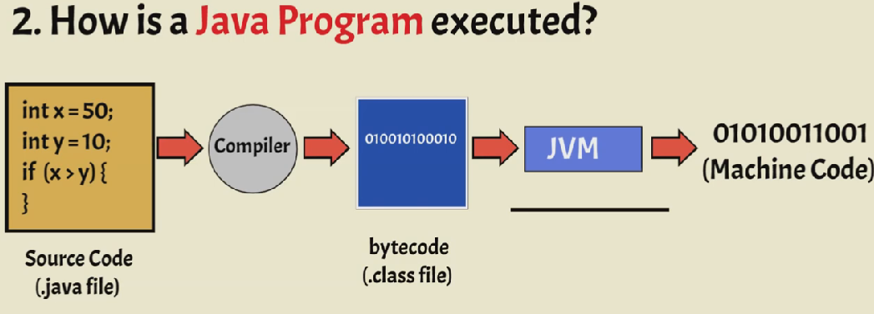

**why java is not purely object oriented programming language**

Java is not a "PURE" Object Oriented Language , because it uses primitive data types such as (int,float,char...etc). The developers of java could have made these primitive data types as objects(like String... etc), but the primitive data types such as int float... are more faster than objects! So, in order to achieve faster execution of java program they kept Primitive data type as it is!!  
  
So Java is said to be 98% Object oriented language but not PURE Object Oriented language!!

Java is not a pure object oriented language because it supports Primitive datatype such as int, byte, long? etc, to be used, which are not objects.

### **What are the main features of OOPs?**

* Inheritance
* Encapsulation
* Polymorphism
* Data Abstraction

### **8. Can you call the base class method without creating an instance?**

Yes, you can call the base class without instantiating it if:

* It is a static method
* The base class is inherited by some other subclass

### **9. What is the difference between a class and an object?**

|  |  |
| --- | --- |
| Object | Class |
| A real-world entity which is an instance of a class | A class is basically a template or a blueprint within which objects can be created |
| An object acts like a variable of the class | Binds methods and data together into a single unit |
| An object is a physical entity | A class is a logical entity |
| Objects take memory space when they are created | A class does not take memory space when created |
| Objects can be declared as and when required | Classes are declared just once |

#### **10. What is inheritance?**

Inheritance is a feature of OOPs which allows classes inherit common properties from other classes. For example, if there is a class such as ‘vehicle’, other classes like ‘car’, ‘bike’, etc can inherit common properties from the vehicle class. This property helps you get rid of redundant code thereby reducing the overall size of the code.

#### **11. What are the different types of inheritance?**

* Single inheritance
* Multiple inheritance
* Multilevel inheritance
* Hierarchical inheritance
* Hybrid inheritance

#### **12. What is the difference between multiple and multilevel inheritance?**

|  |  |
| --- | --- |
| Multiple Inheritance | Multilevel Inheritance |
| Multiple inheritance comes into picture when a class inherits more than one base class | Multilevel inheritance means a class inherits from another class which itself is a subclass of some other base class |
| Example: A class defining a child inherits from two base classes Mother and Father | Example: A class describing a sports car will inherit from a base class Car which inturn inherits another class Vehicle |

#### **13. What is hybrid inheritance?**

Hybrid inheritance is a combination of multiple and multi-level inheritance.

#### **14. What is hierarchical inheritance?**

Hierarchical inheritance refers to inheritance where one base class has more than one subclasses. For example, the vehicle class can have ‘car’, ‘bike’, etc as its subclasses.

#### **15. What are the limitations of inheritance?**

* Increases the time and effort required to execute a program as it requires jumping back and forth between different classes
* The parent class and the child class get tightly coupled
* Any modifications to the program would require changes both in the parent as well as the child class
* Needs careful implementation else would lead to incorrect results

#### **16. What is a superclass?**

A superclass or base class is a class that acts as a parent to some other class or classes. For example, the Vehicle class is a superclass of class Car.

#### **28. What is data abstraction?**

Data abstraction is a very important feature of OOPs that allows displaying only the important information and hiding the implementation details. For example, while riding a bike, you know that if you raise the accelerator, the speed will increase, but you don’t know how it actually happens. This is [data abstraction](https://www.edureka.co/blog/data-abstraction-in-cpp/) as the implementation details are hidden from the rider.

#### **29. How to achieve data abstraction?**

Data abstraction can be achieved through:

* Abstract class
* Abstract method

#### **30. What is an abstract class?**

An abstract class is a class that consists of abstract methods. These methods are basically declared but not defined. If these methods are to be used in some subclass, they need to be exclusively defined in the subclass.

#### **31. Can you create an instance of an abstract class?**

No. Instances of an abstract class cannot be created because it does not have a complete implementation. However, instances of subclass inheriting the abstract class can be created.

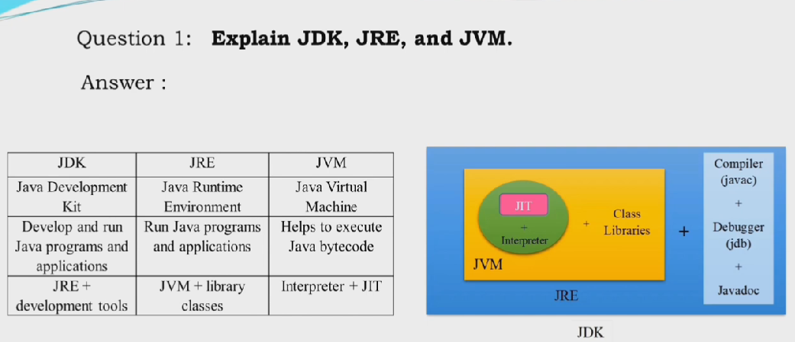

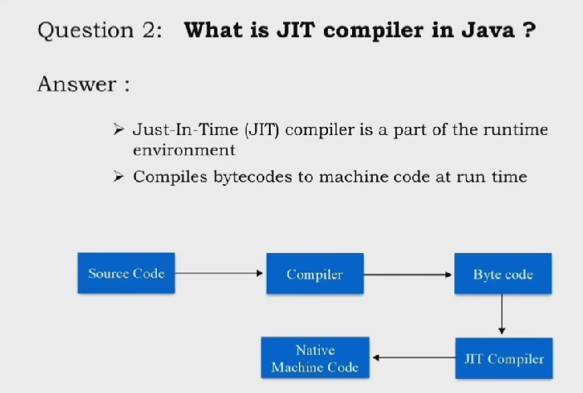

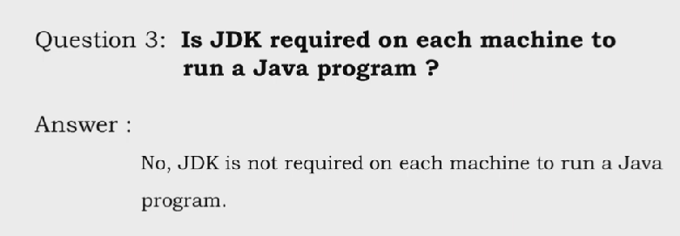

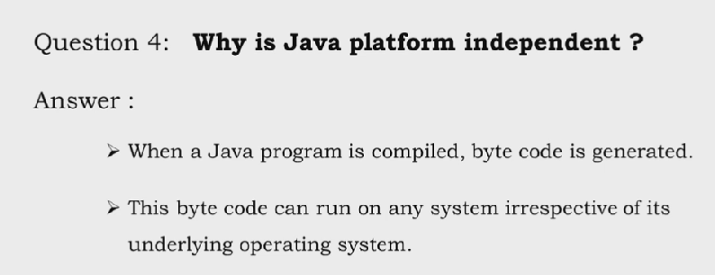

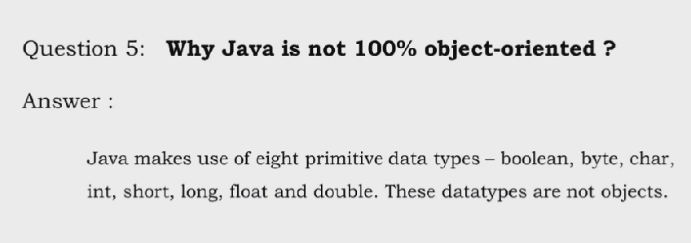

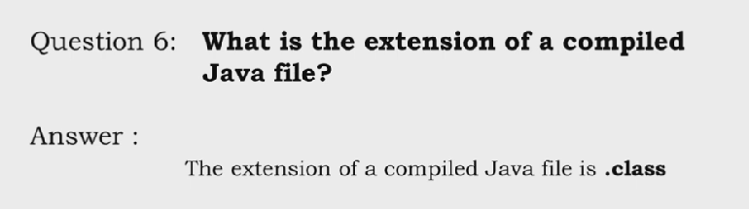

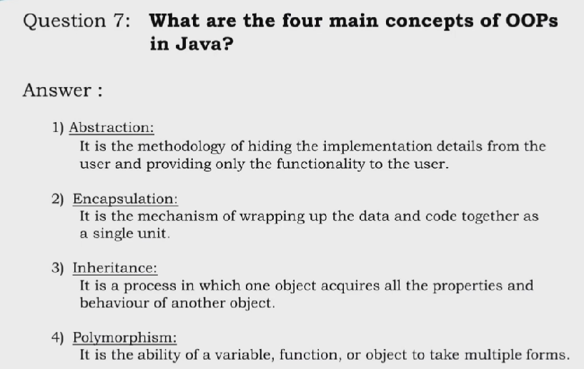

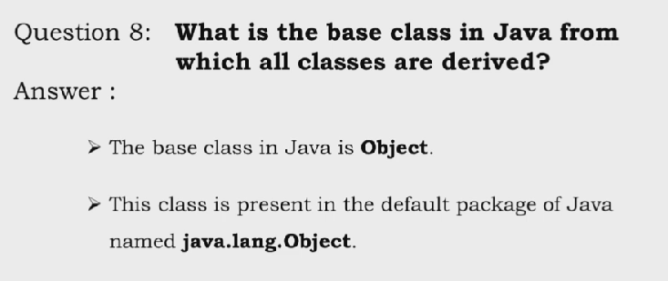

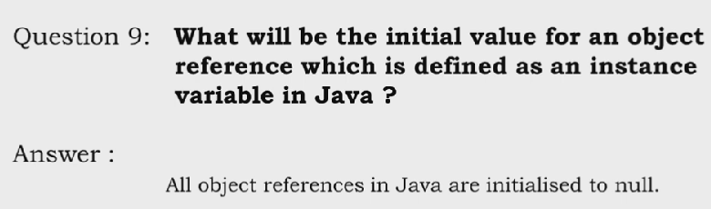

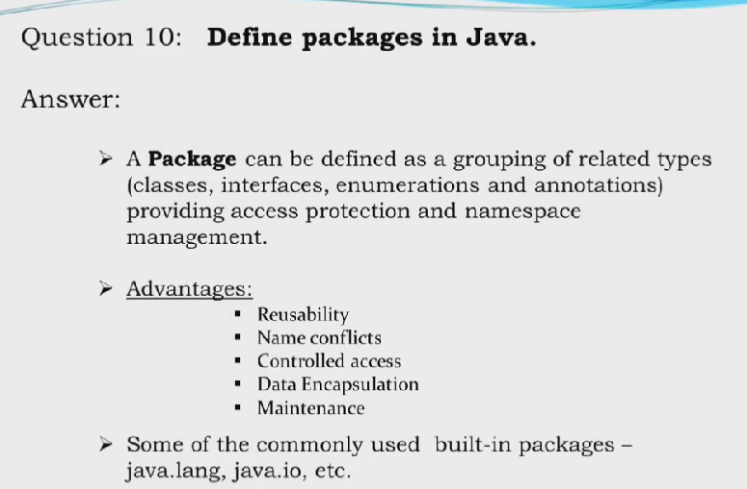

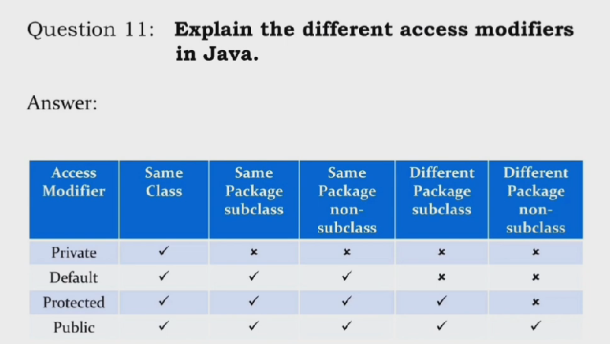

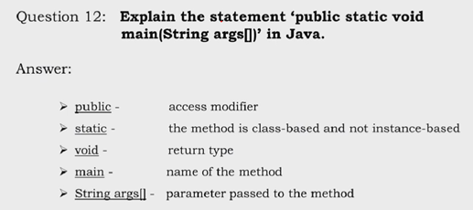

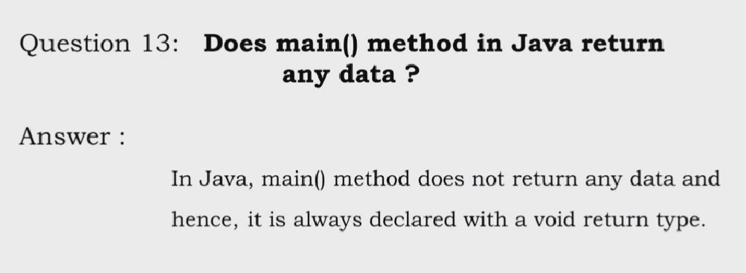

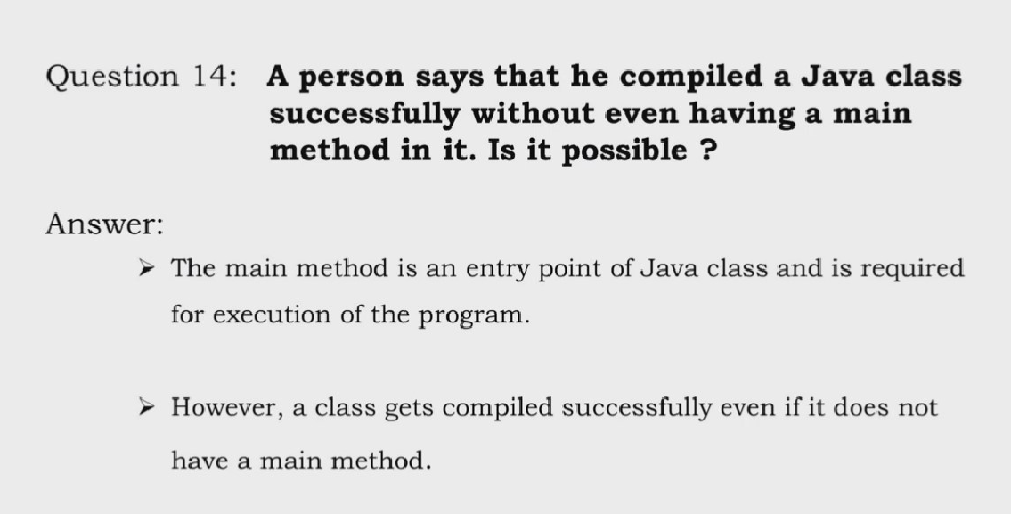

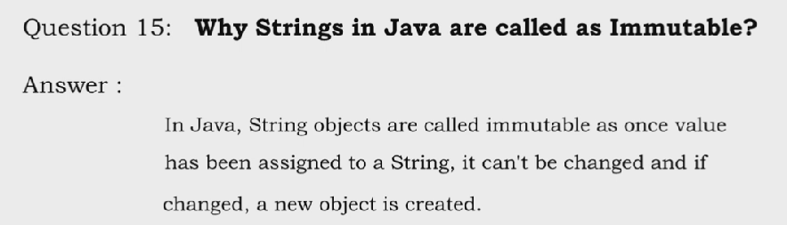

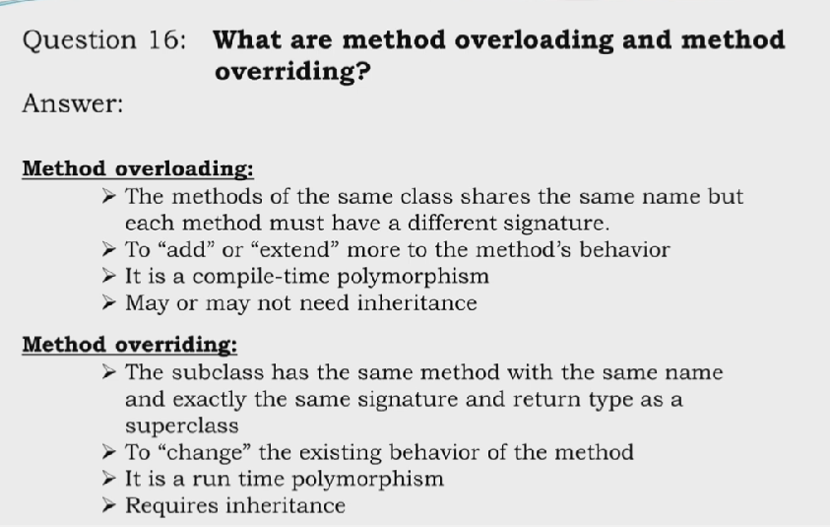

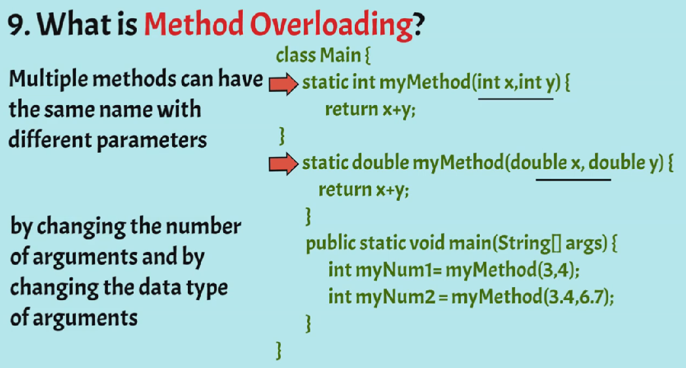

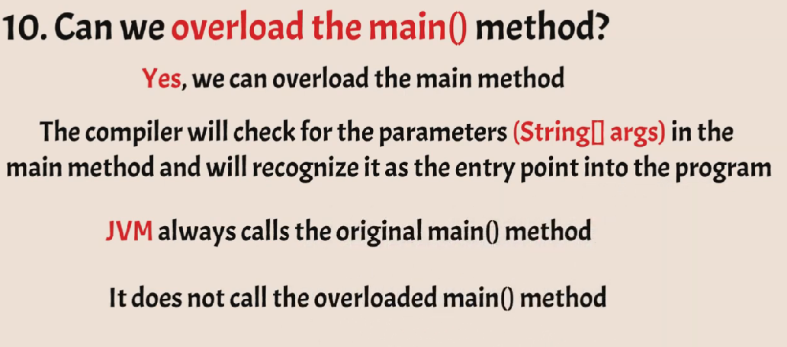

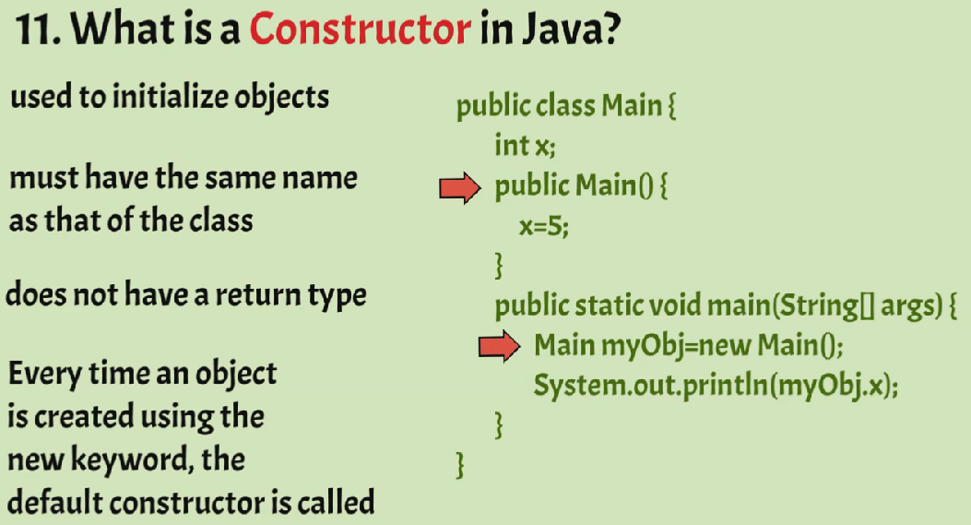

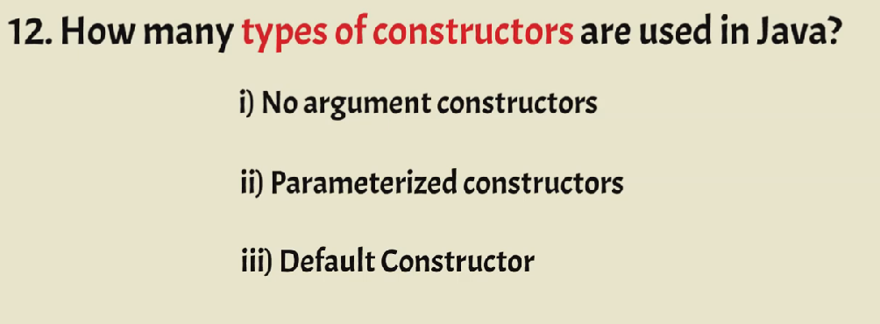

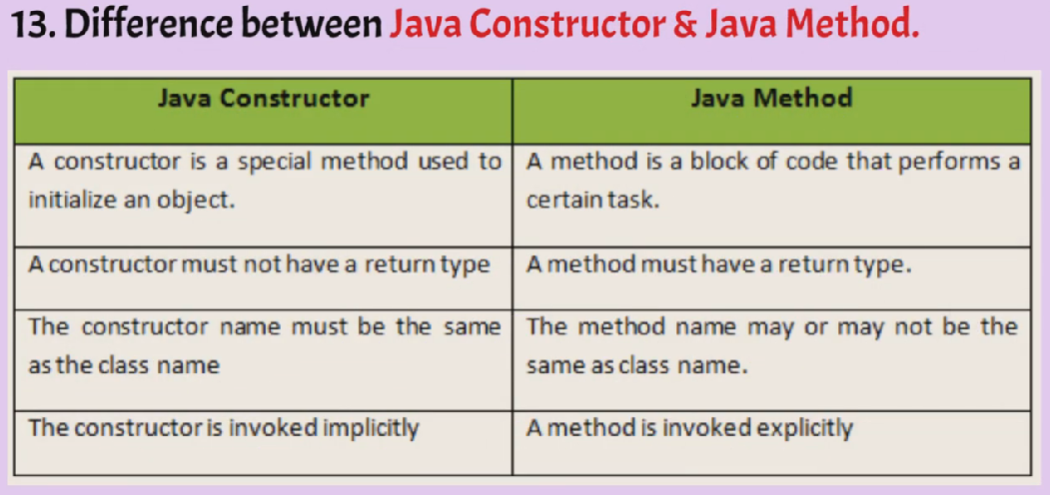

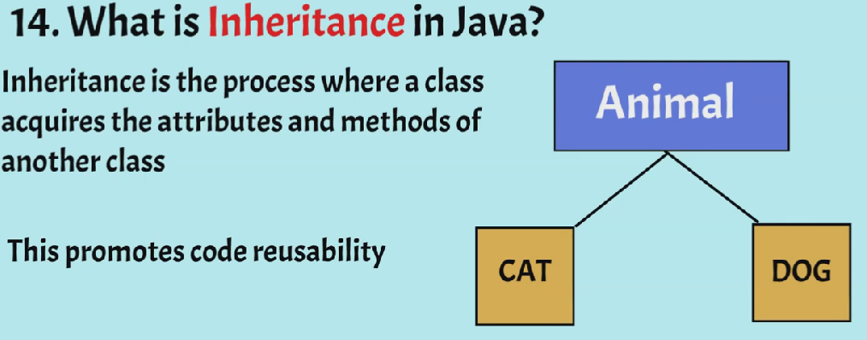

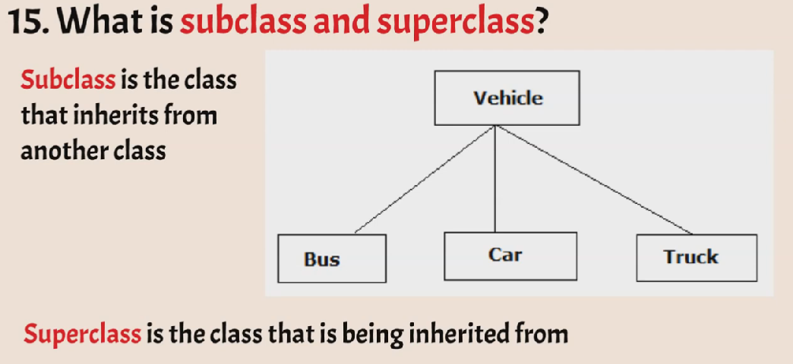

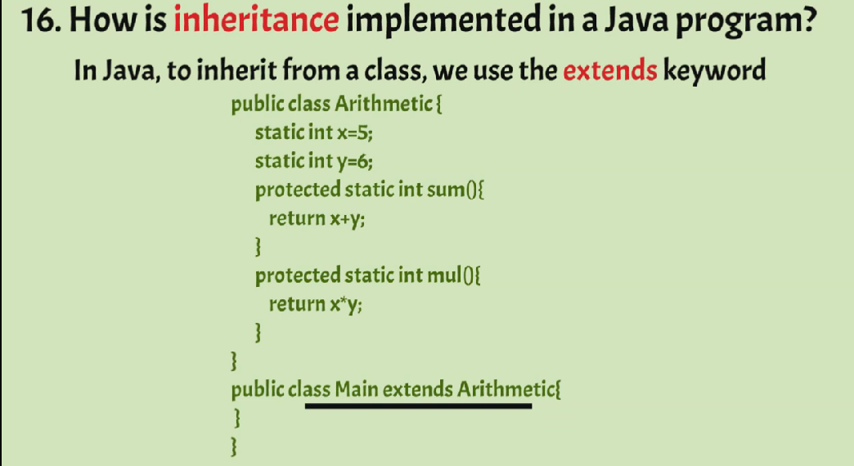

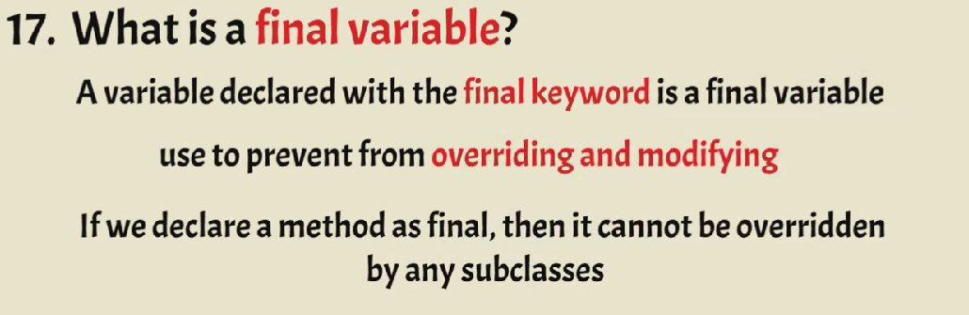

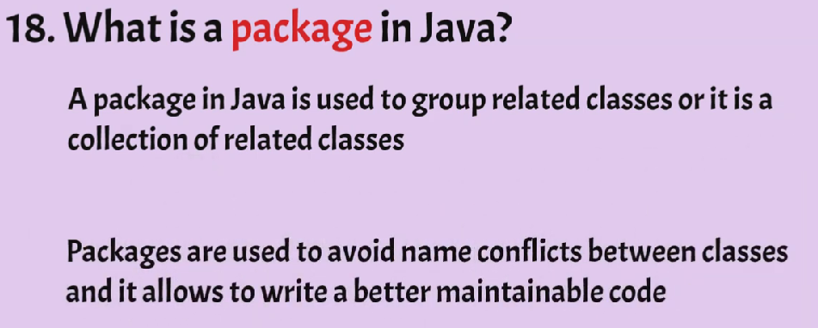

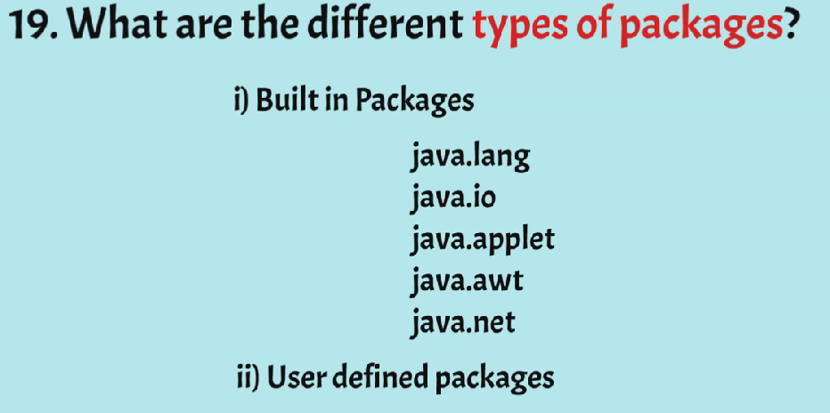

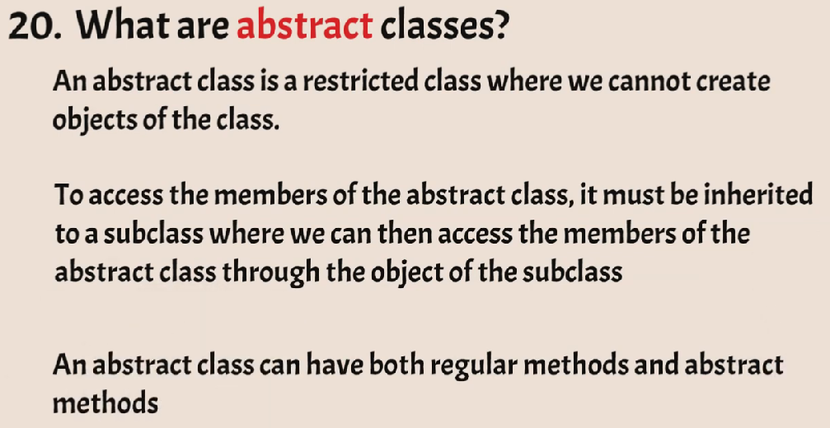

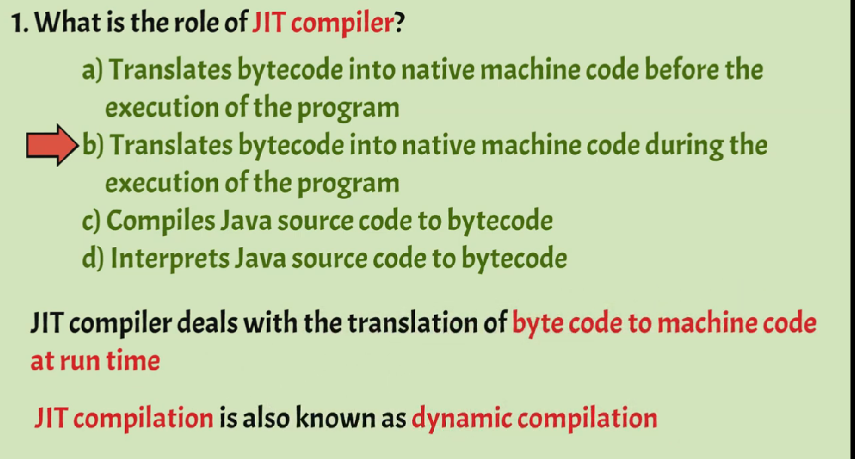

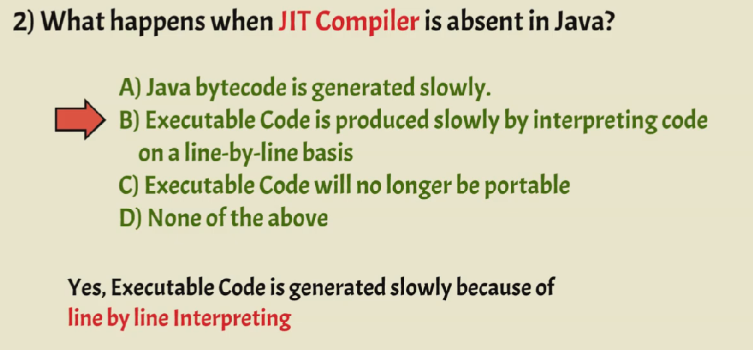

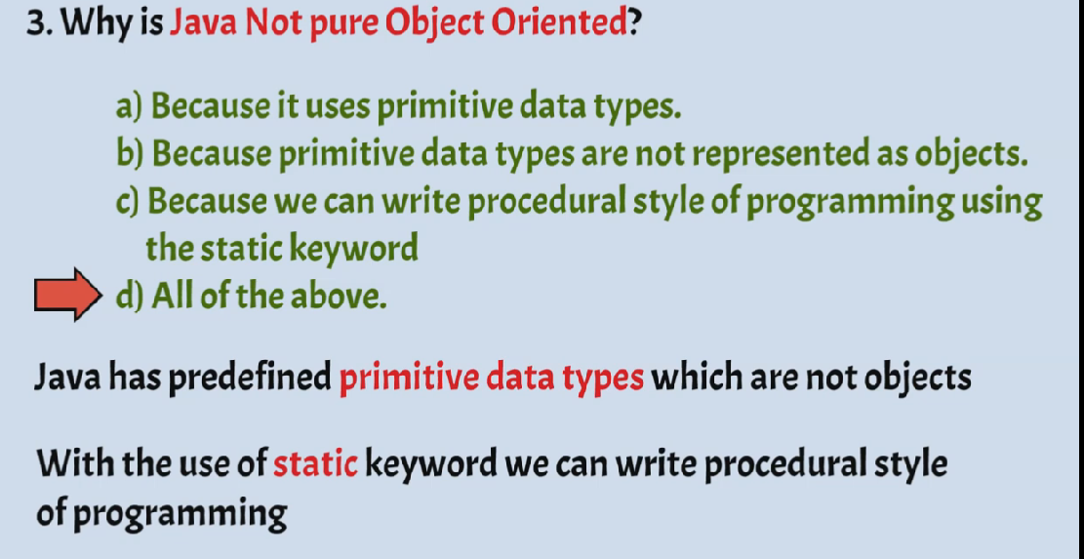

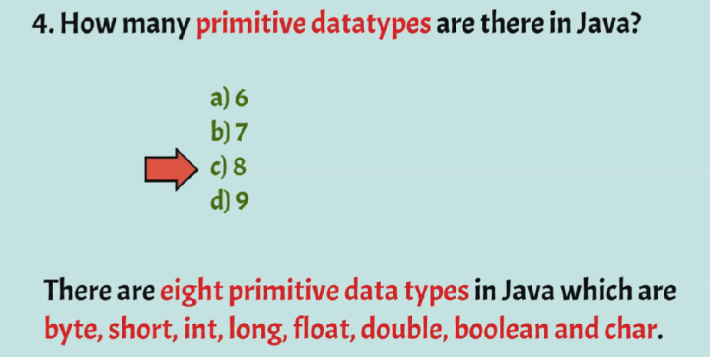

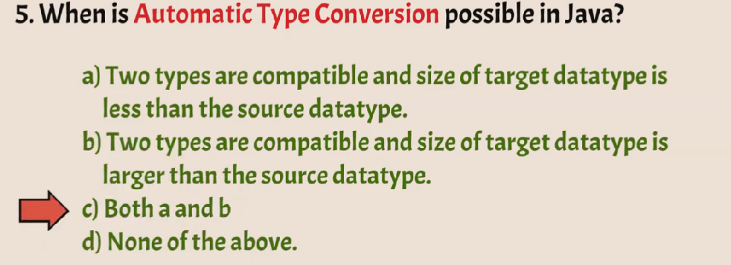

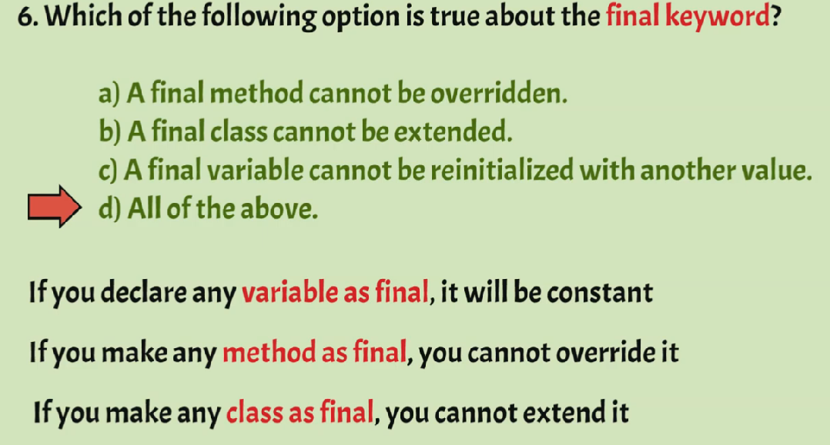

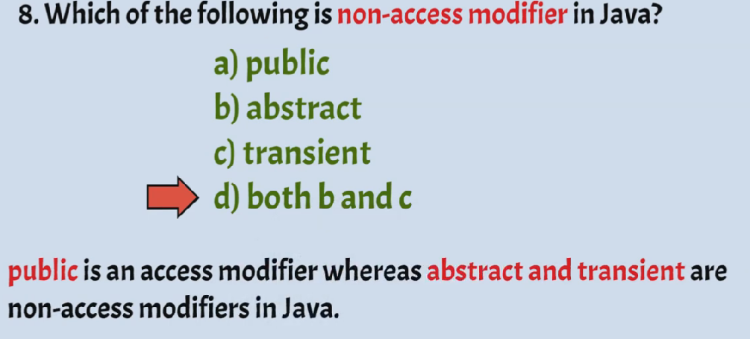

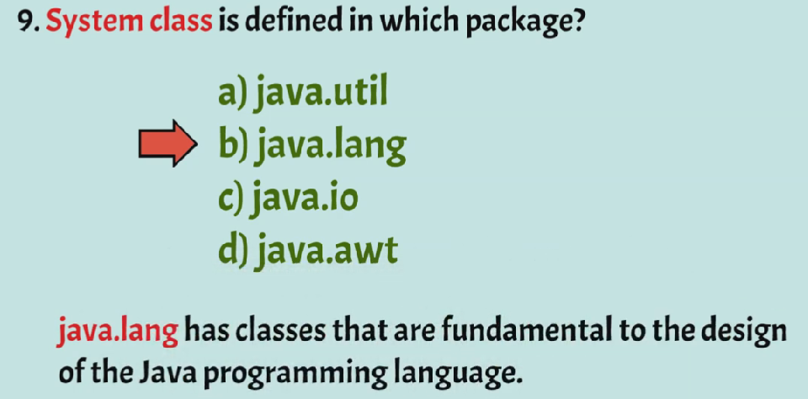

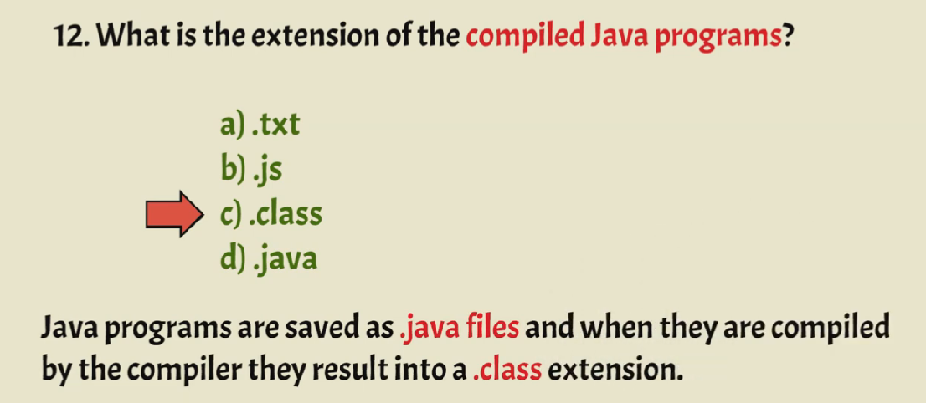

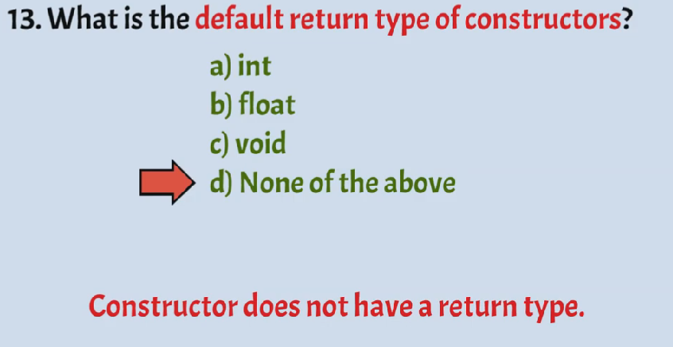

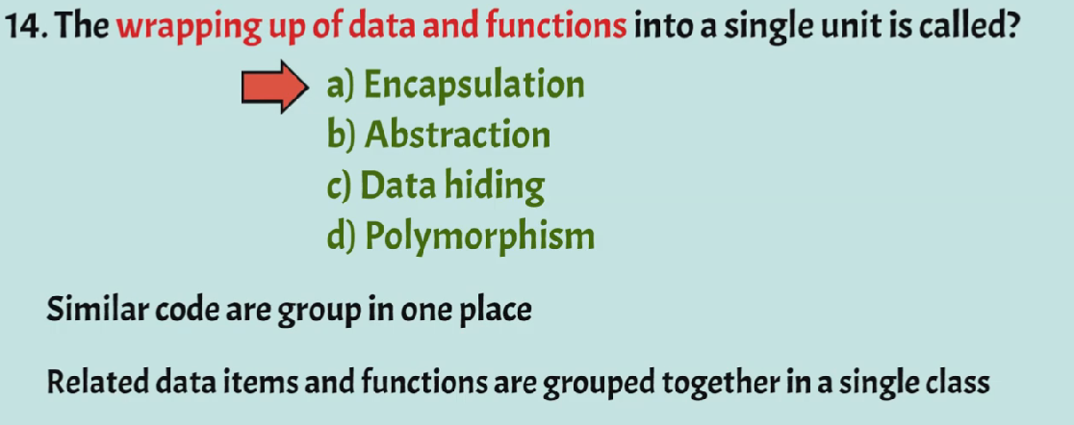

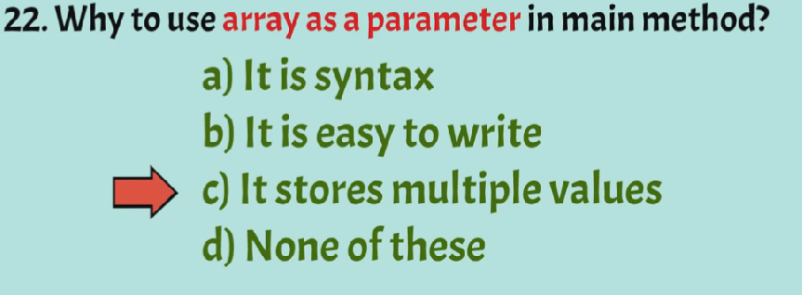

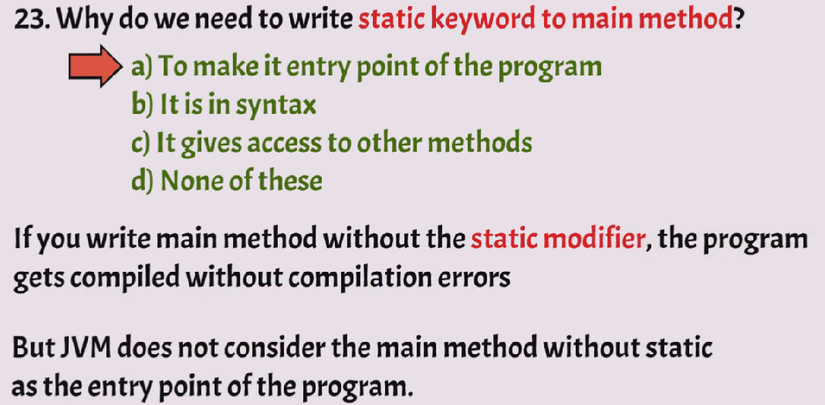

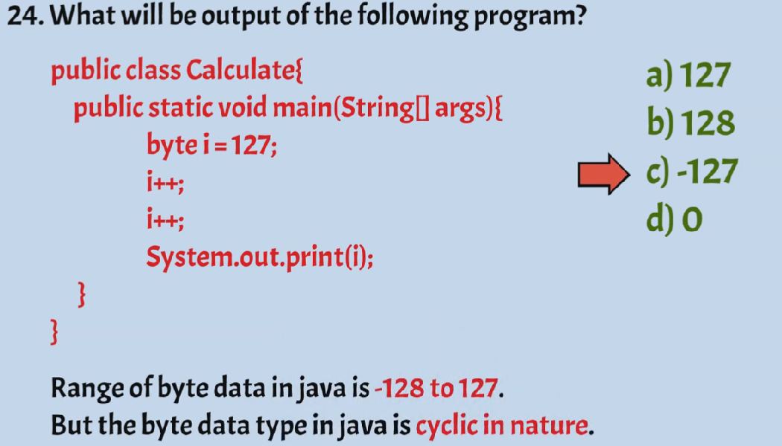

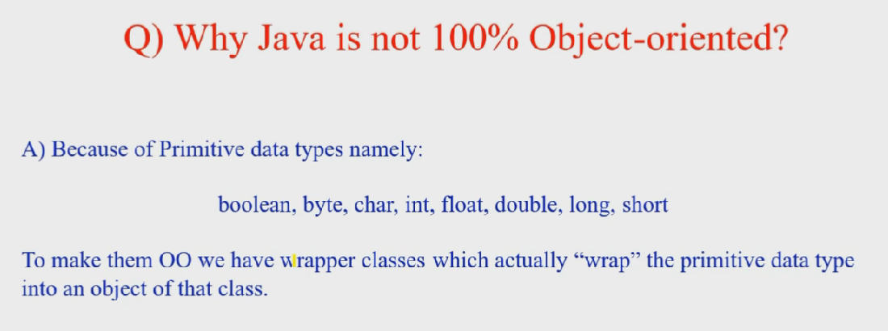

Can be private static final overloaded but not override

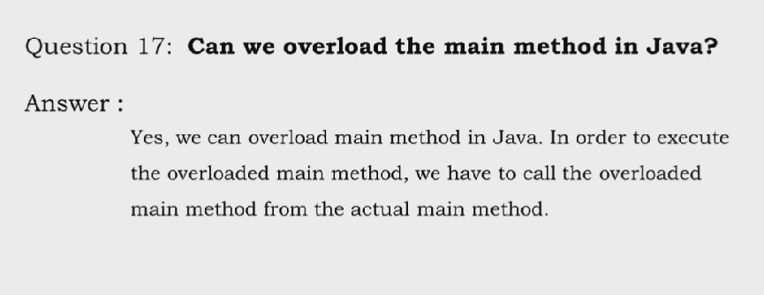

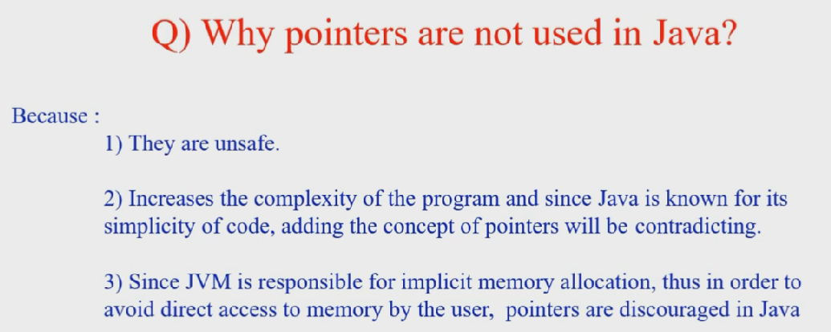

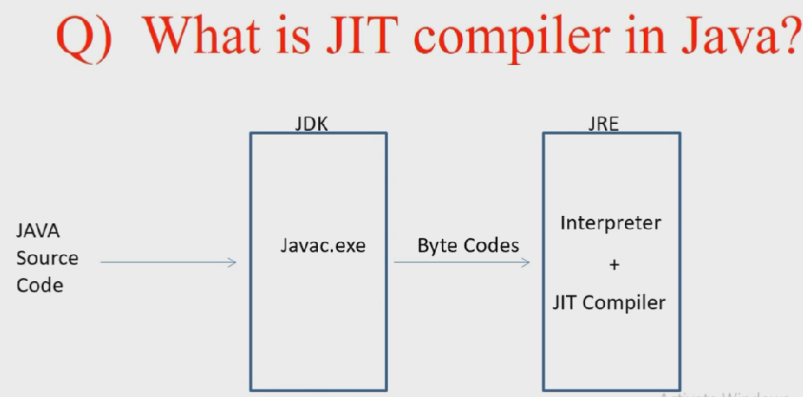

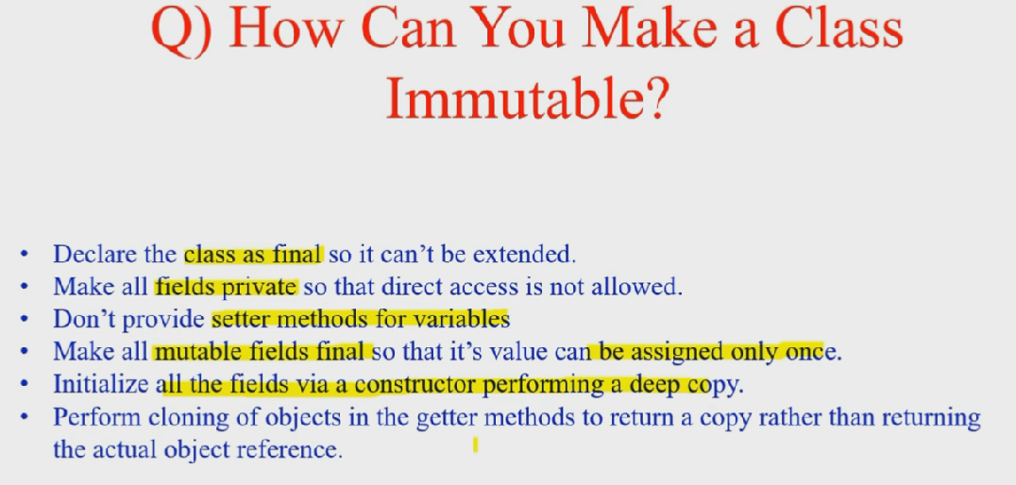

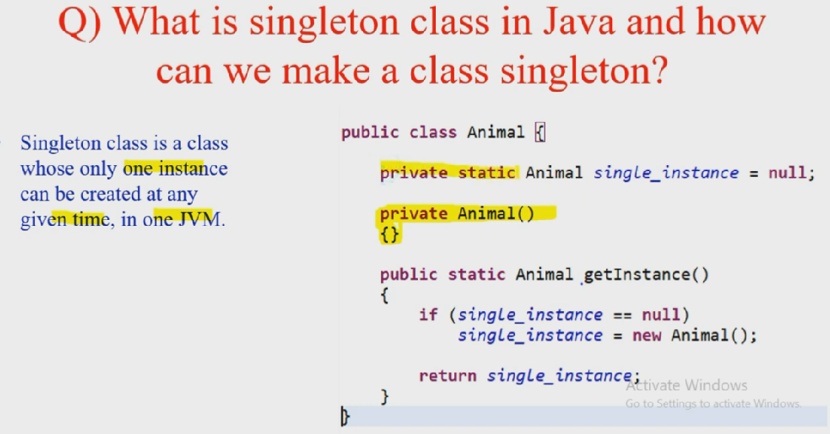

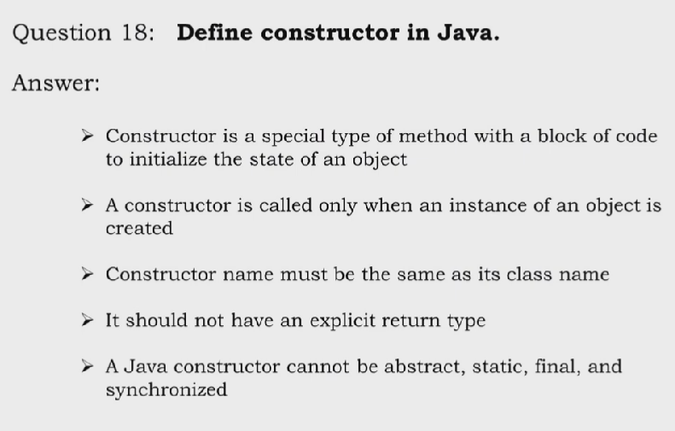

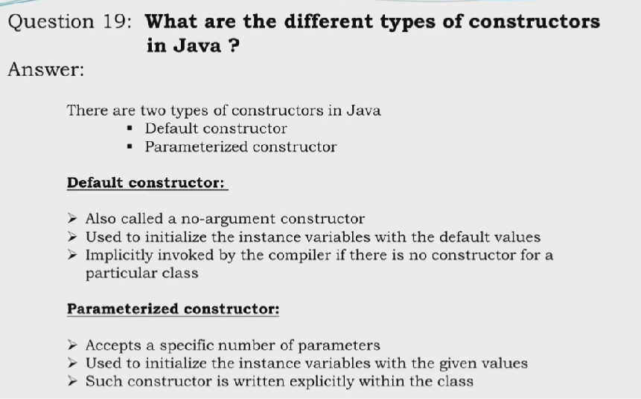

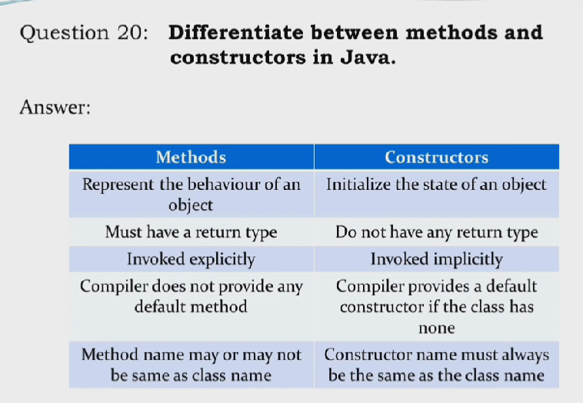

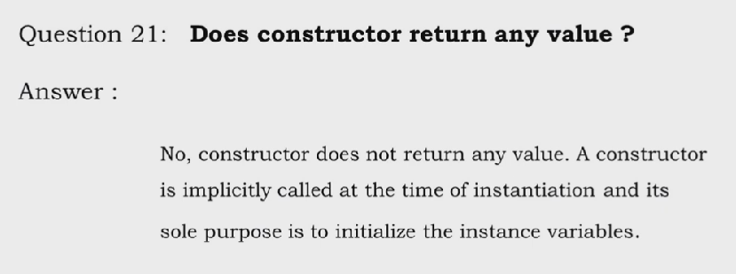

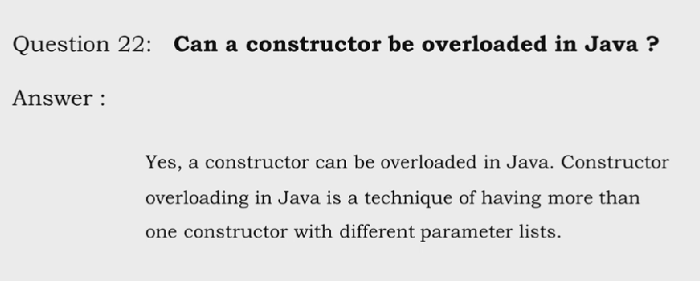

Yes but not override

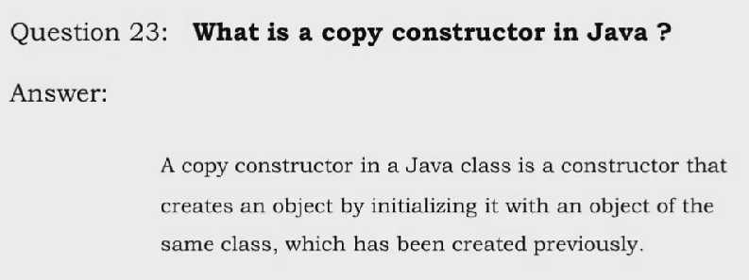

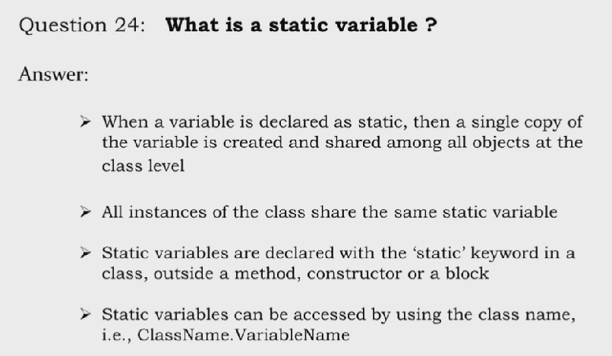

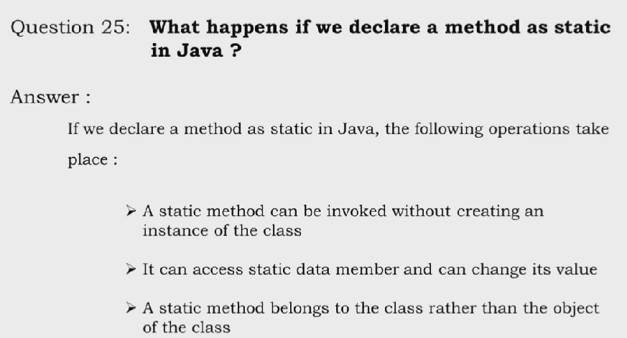

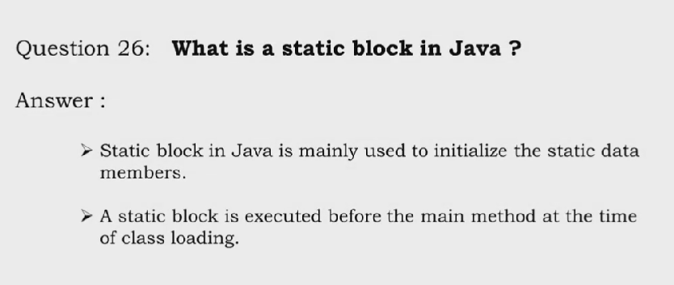

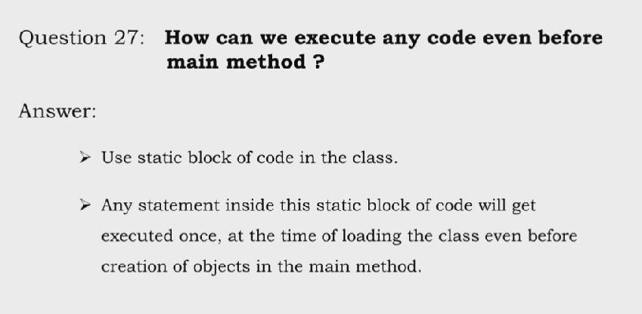

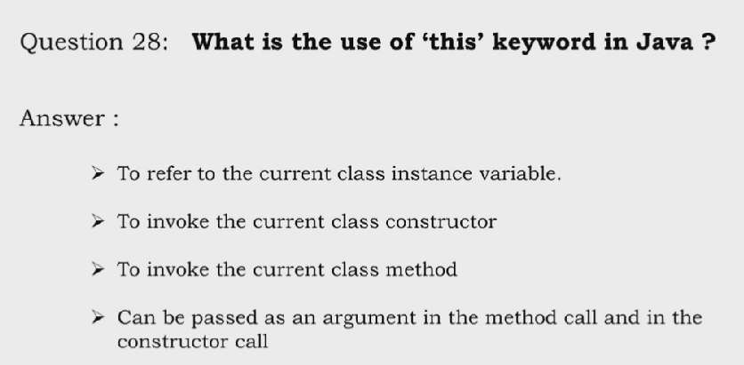

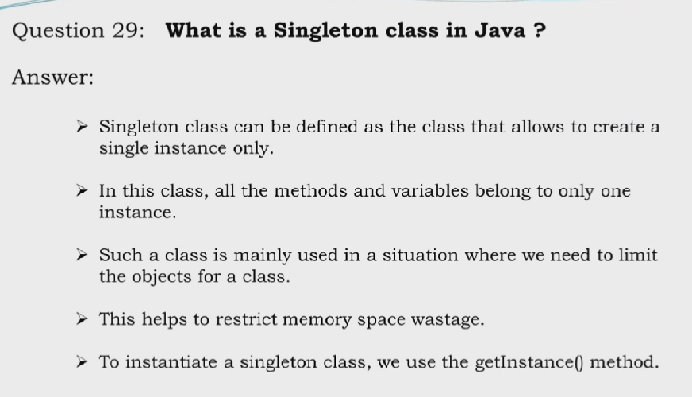

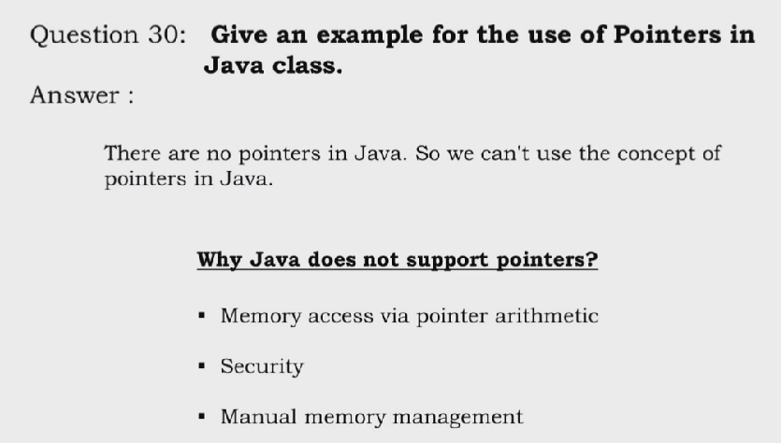

## **What are the different ways to create an object in Java?**

There are many ways to create an object in java. They are:

* By new keyword
* By newInstance() method
* By clone() method
* By deserialization
* By factory method etc.

